Approximate Numerals

✅ Definition:
# Source: AI Source: Provided by: [Data Path: Persons Table -> ID Column: 1, Name_En Column: Motasem Essam] -> From: [Chatgpt (GPT-4-turbo)] on [7/28/2025]
Approximate numerals express non-exact, estimated, or indefinite quantities.
They answer questions like:
- "About how many?"
- "Roughly how much?"
They give a sense of number without precision.

🧩 Common Approximate Numerals:
# Source: AI Source: Provided by: [Data Path: Persons Table -> ID Column: 1, Name_En Column: Motasem Essam] -> From: [Chatgpt (GPT-4-turbo)] on [7/28/2025]
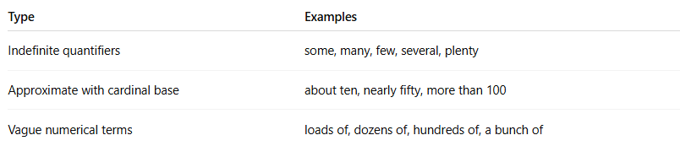
Type | Examples
Indefinite quantifiers | some, many, few, several, plenty
Approximate with cardinal base | about ten, nearly fifty, more than 100
Vague numerical terms | loads of, dozens of, hundreds of, a bunch of

✏️ Examples in Sentences:
# Source: AI Source: Provided by: [Data Path: Persons Table -> ID Column: 1, Name_En Column: Motasem Essam] -> From: [Chatgpt (GPT-4-turbo)] on [7/28/2025]
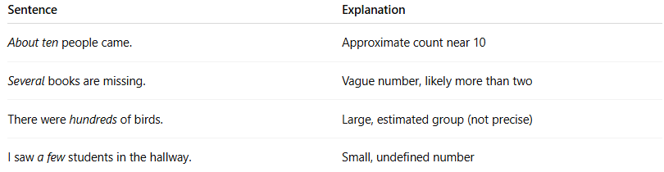
Sentence | Explanation
About ten people came. | Approximate count near 10
Several books are missing. | Vague number, likely more than two
There were hundreds of birds. | Large, estimated group (not precise)
I saw a few students in the hallway. | Small, undefined number

📌 Grammatical Functions:
# Source: AI Source: Provided by: [Data Path: Persons Table -> ID Column: 1, Name_En Column: Motasem Essam] -> From: [Chatgpt (GPT-4-turbo)] on [7/28/2025]
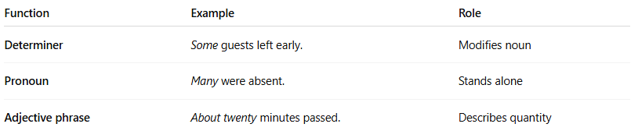
Function | Example | Role
Determiner | Some guests left early. | Modifies noun
Pronoun | Many were absent. | Stands alone
Adjective phrase | About twenty minutes passed. | Describes quantity

🔍 Properties of Approximate Numerals:
# Source: AI Source: Provided by: [Data Path: Persons Table -> ID Column: 1, Name_En Column: Motasem Essam] -> From: [Chatgpt (GPT-4-turbo)] on [7/28/2025]
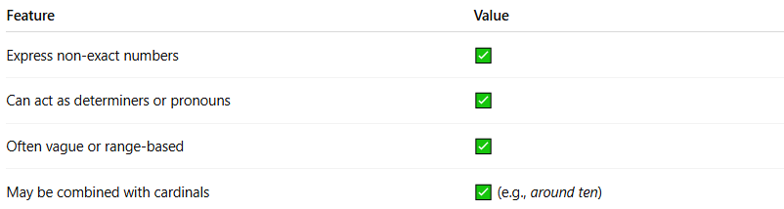
Feature | Value
Express non-exact numbers | ✅
Can act as determiners or pronouns | ✅
Often vague or range-based | ✅
May be combined with cardinals | ✅ (e.g., around ten)

⚠️ Note:
# Source: AI Source: Provided by: [Data Path: Persons Table -> ID Column: 1, Name_En Column: Motasem Essam] -> From: [Chatgpt (GPT-4-turbo)] on [7/28/2025]
- Approximate ≠ Cardinal:
  - Ten = exact
  - About ten = estimate
- Approximate ≠ Quantifier (entirely):
  - While some approximate numerals are quantifiers (like many, few), not all quantifiers are numerals (e.g., all, most, none).
- Some linguists exclude approximate numerals from strict numeral classification and consider them quantifiers instead — but they do serve a numerical function semantically.

🧠 Summary:
# Source: AI Source: Provided by: [Data Path: Persons Table -> ID Column: 1, Name_En Column: Motasem Essam] -> From: [Chatgpt (GPT-4-turbo)] on [7/28/2025]
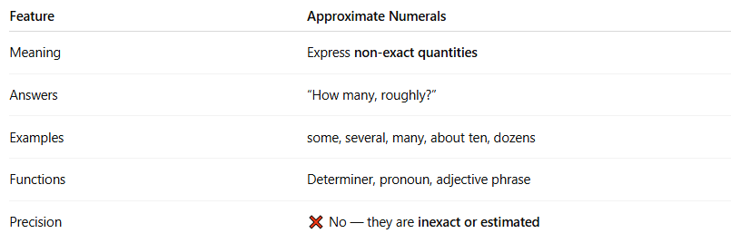
Feature | Approximate Numerals
Meaning | Express non-exact quantities
Answers | “How many, roughly?”
Examples | some, several, many, about ten, dozens
Functions | Determiner, pronoun, adjective phrase
Precision | ❌ No — they are inexact or estimated

